Instructions for running unit test:

Clone the repo, open the file SpecRunner.html in the browser. You would see a page like this:

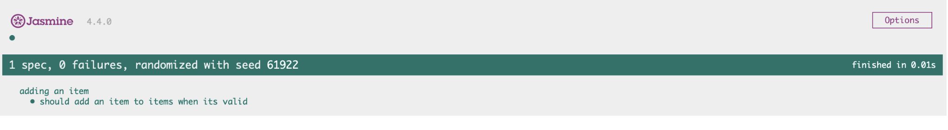

Instructions for web application:

1. Use the url: <https://csc301-fall-2022.github.io/assignment-2-93-zijin523-jess-zhai/src/checkout.html>

Or, after cloning the repo, Click the checkout.html file in /src folder , open it in the browser, it should lead to the web page of the application.

1. View all items you can add to cart by clicking on the “All Products” menu.

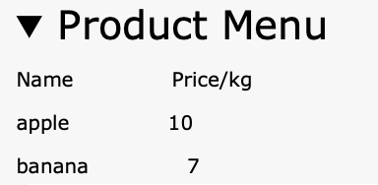

1. The “Product” and “Price/kg” below it is a simplified feature to add new kinds of products that customers can buy.

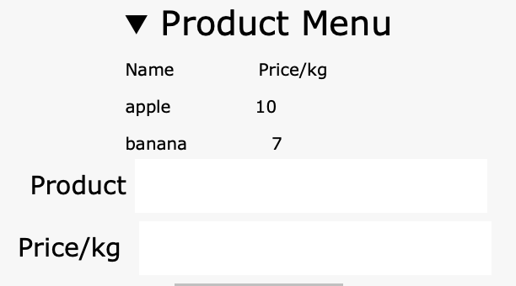

1. Input the name of the new product you want, and its price. Then, press the “Add” button below it.

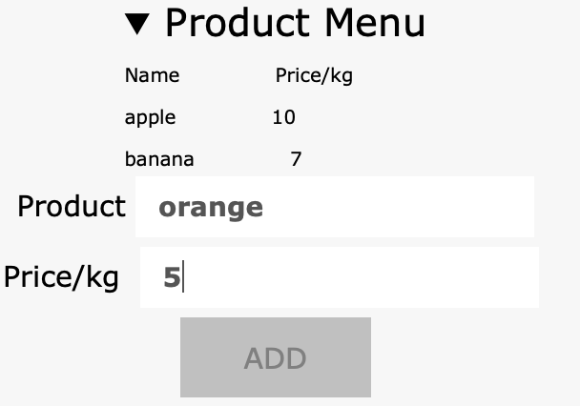

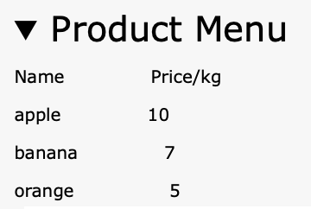

1. To delete an existing product, enter its name in the “Product Name” textbox, and press “Delete” button below it.

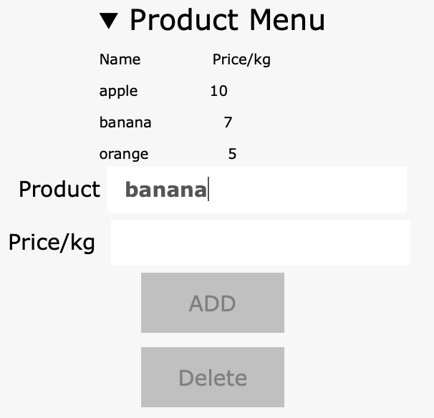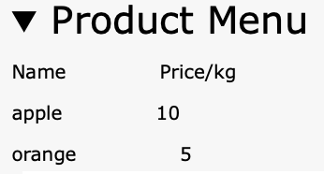

1. Add an item into the cart by entering its name, the amount, and the discount related to the item in the textboxes below. Note that discounts can not be added alone. The subtotal and the tax will be automatically displayed above.

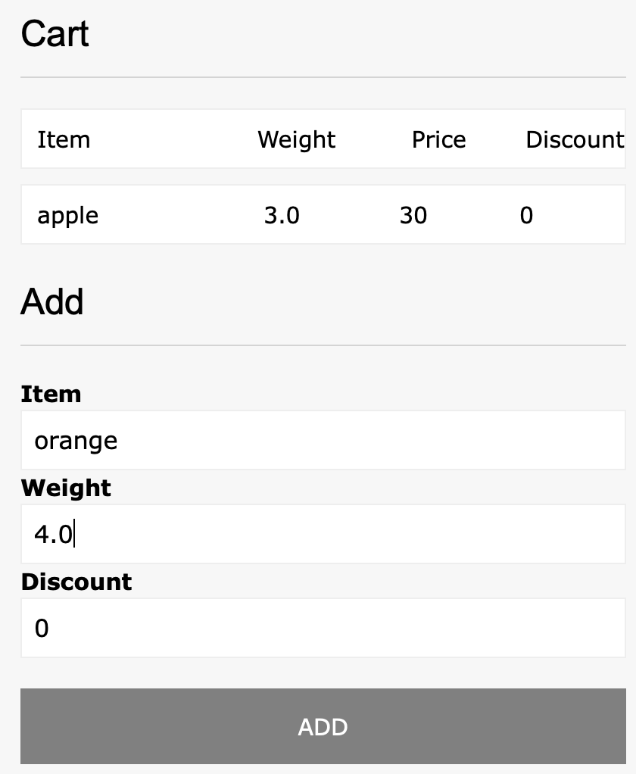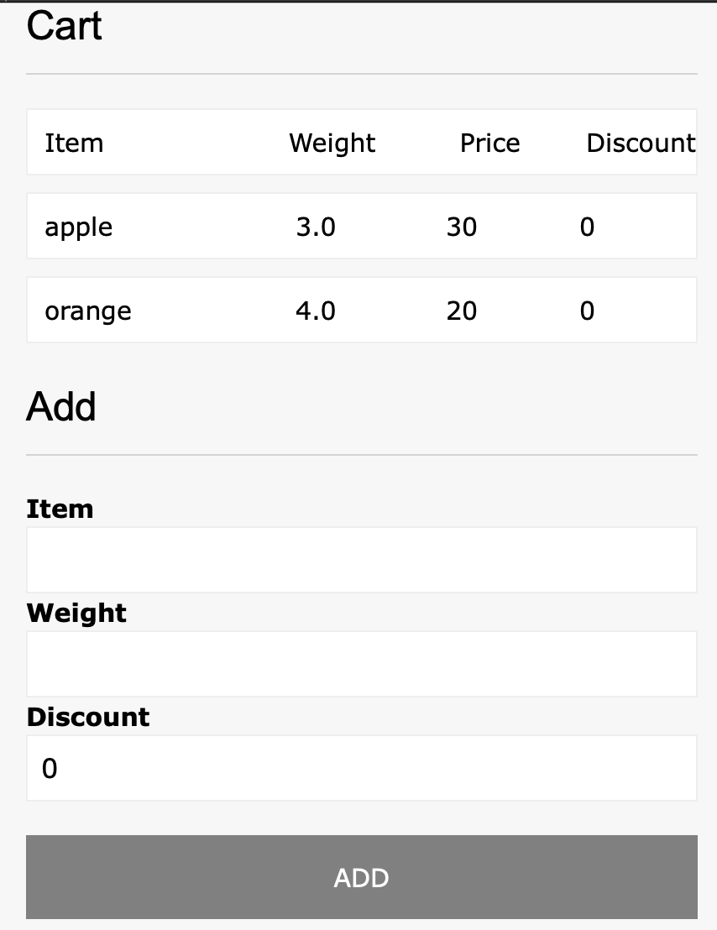

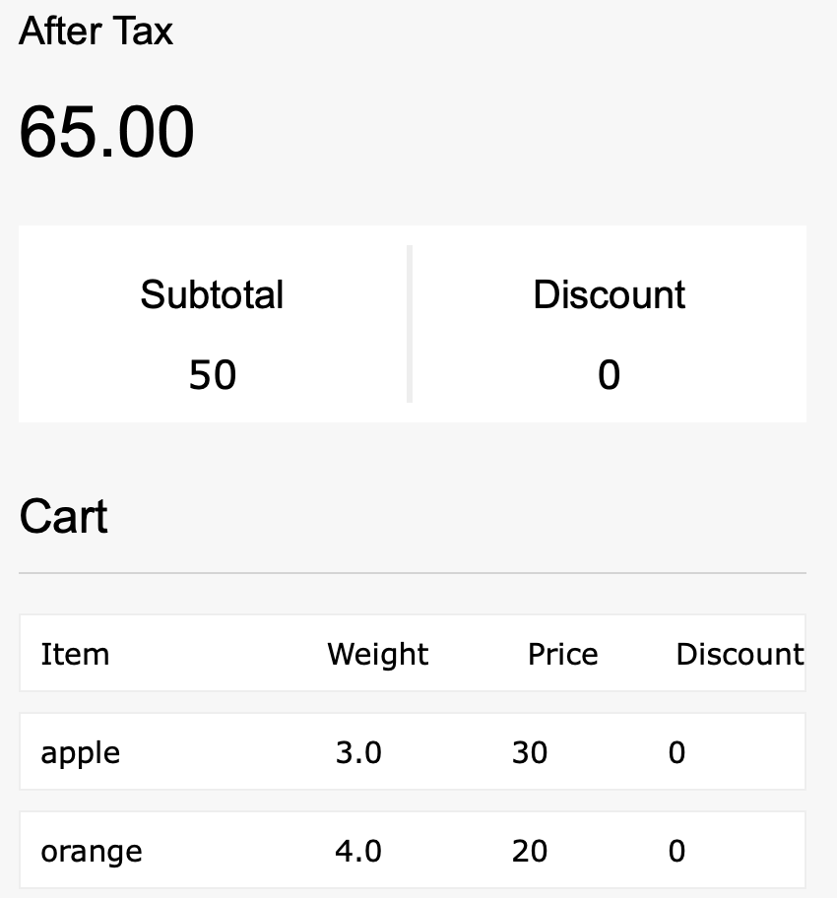

1. To delete an item from the cart, click on the product in the cart, and click it again to deselect it. After selecting all items you want to remove, click “Delete” at the bottom.

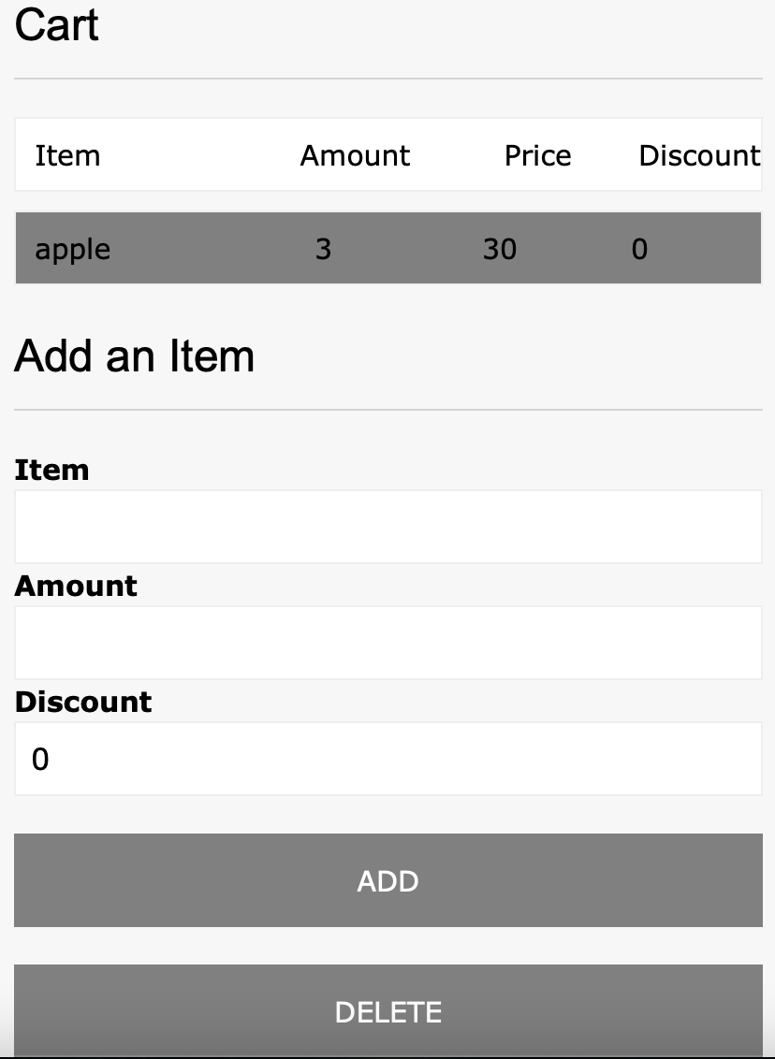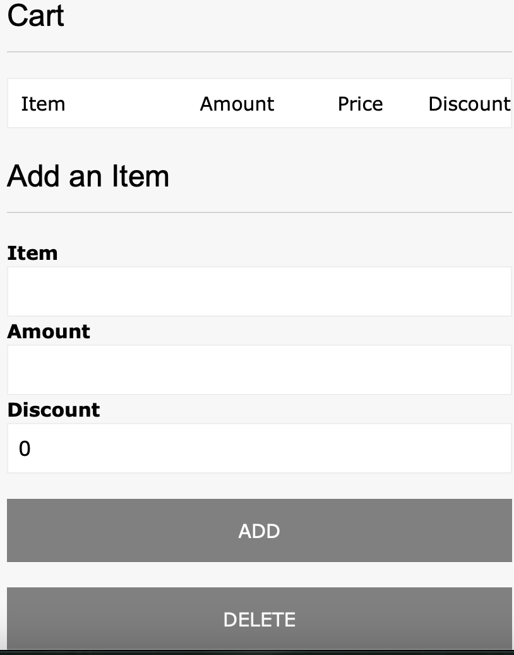

1. To apply discount, enter it with the items when adding it into the cart.

